The Birds.zip file on Canvas (the 2 copies in 2 different folders are *now* identical) contain a Birds.mdf file.

Download, upzip, put the MDF file in the /users/Public folder, and then use SSMS to do an “attach” to that file in that location. I have done this and it works. If it doesn’t for you, please manually create your own **Birds** database like this one.

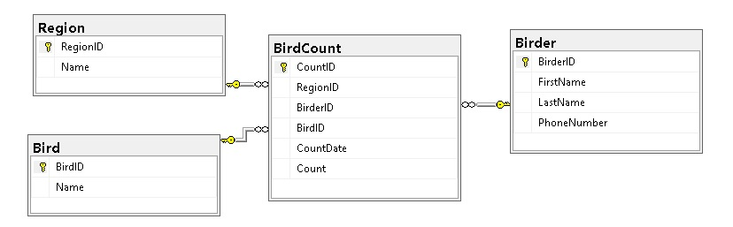

All the ID fields and the Count are data type **int**.

All the Name and the Phone Number are data type **nvarchar(50)**

The CountDate is data type **date**.

Note which fields are marked as Primary Keys, and those fields must have the identity property set to true.

Make a SQL diagram and add the 3 Primary secondary key relationships.

If during class you used the Birds.ZIP file and got the “backup” copy from the 001- Various Database Sources folder, you have a DB with some incorrect data types. Please delete it and rebuild it as above.

Here are the values we started with in the tables:

